**ROYAL AI HOMEWORK-GRAD. DESCENT**

* **Effect of changing the initial values**

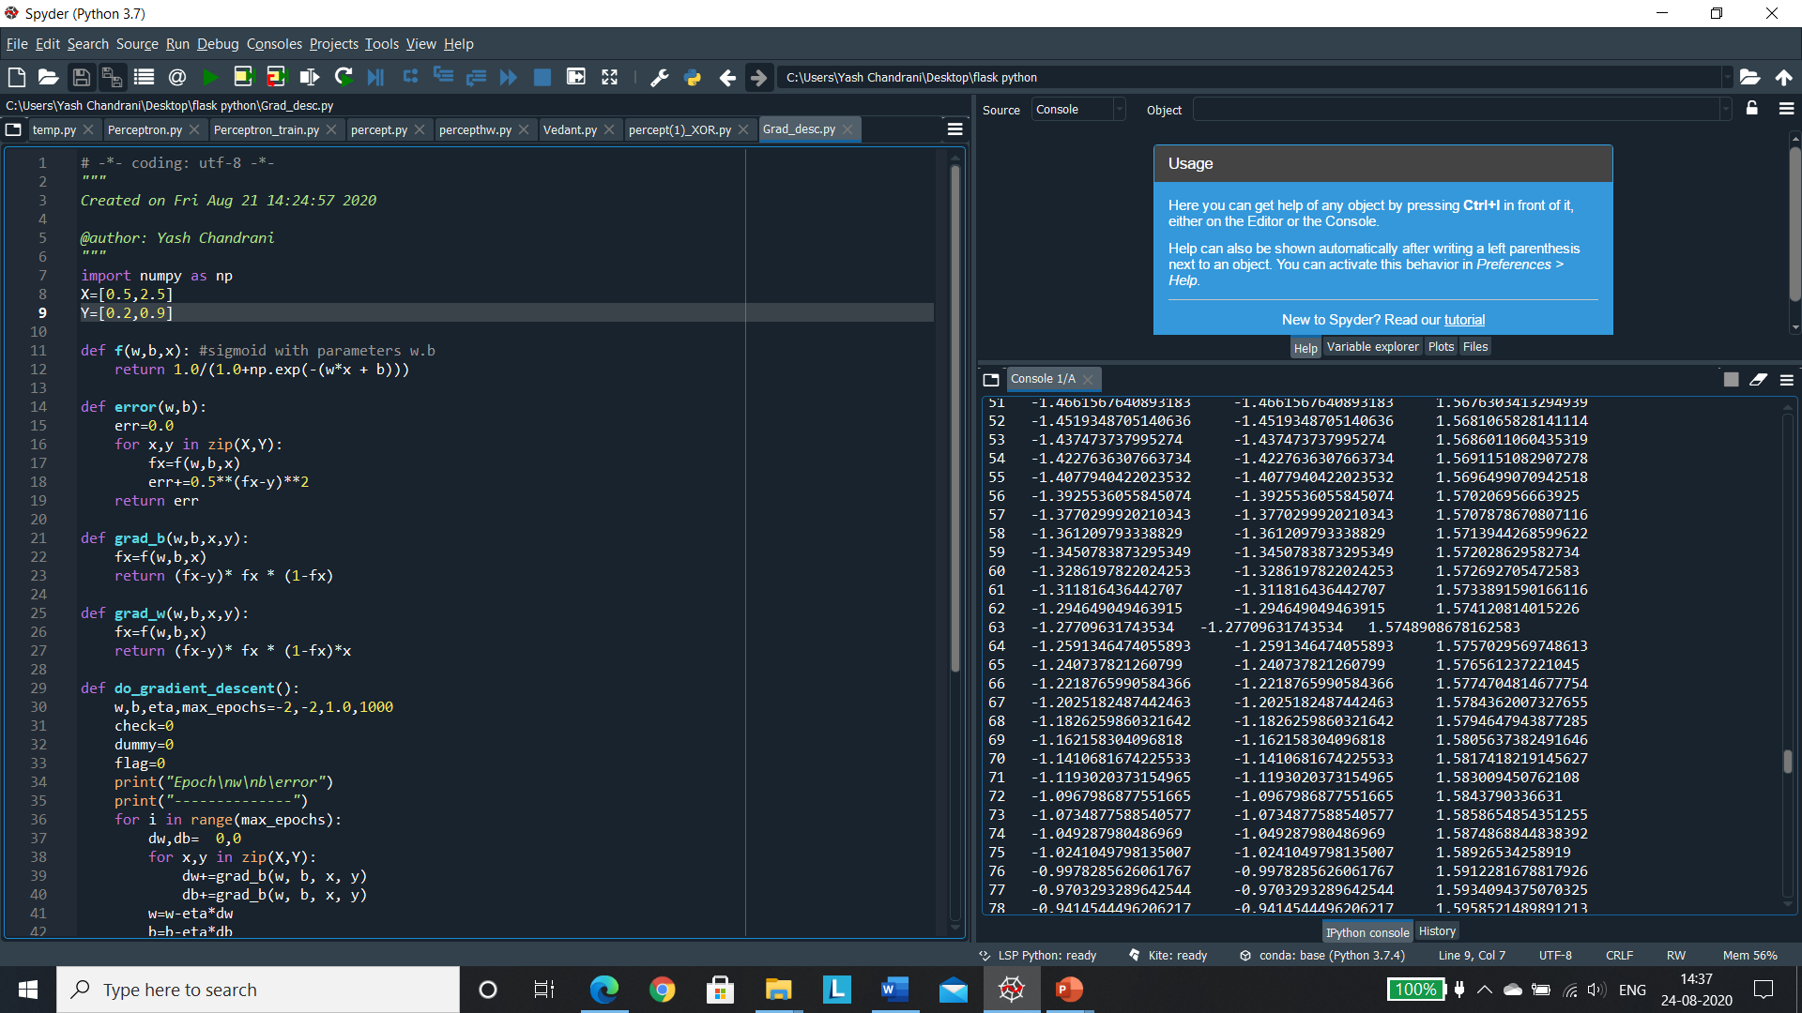

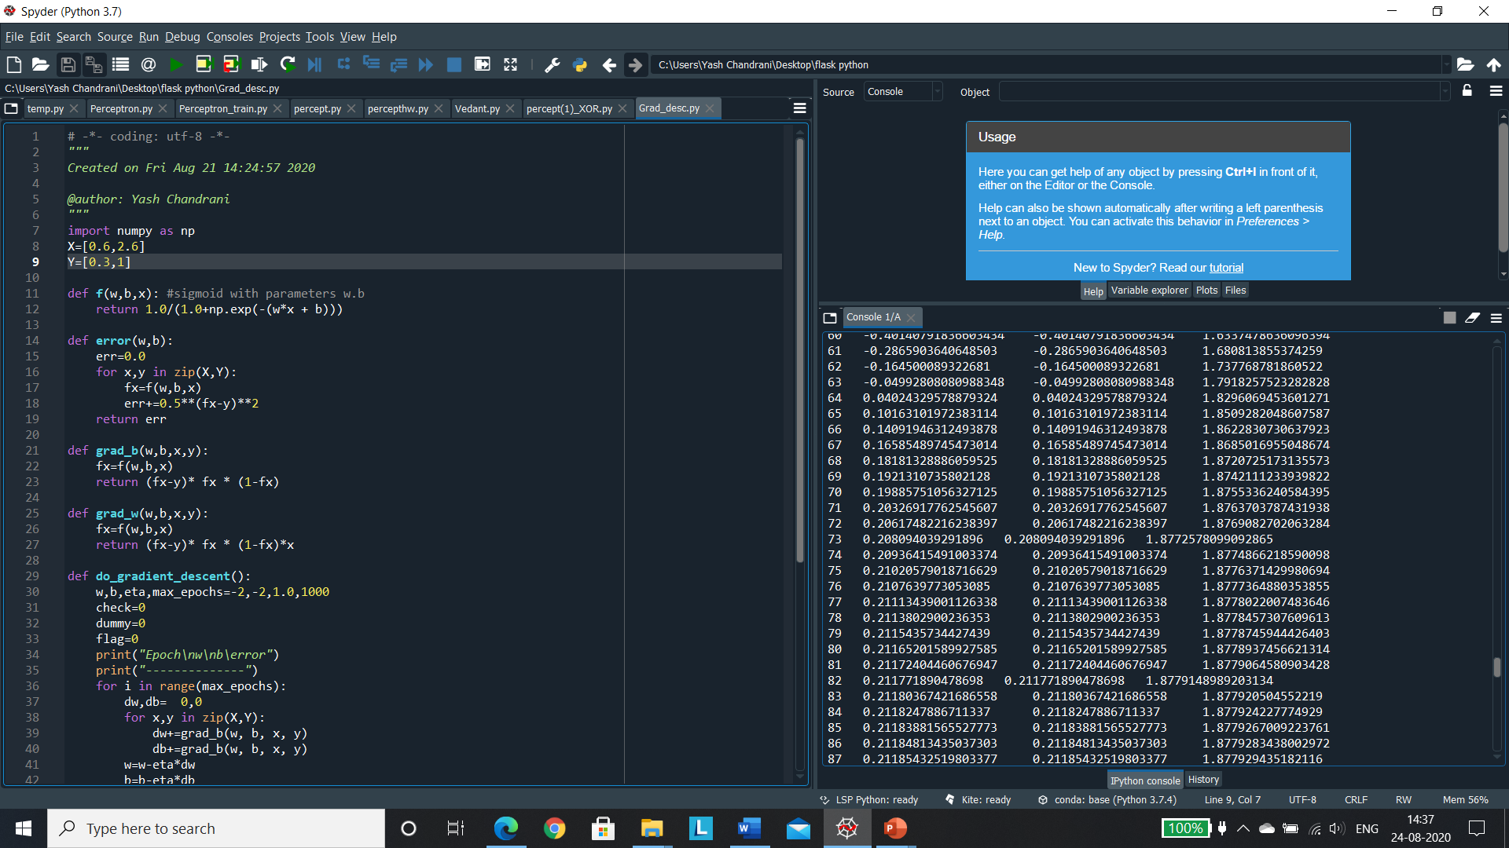

On changing the initial values we experience a change in the rate of weights and bias.

* **Effect of learning rate**

Effect of learning rate changes the number of iterations and hence the number of epochs too.

* **Add more data-points and check the result.**

Changing the weights and bias does not affect the value of error.